fl

Add cover Add comment

**Interest Rate Differentials**

**Central Bank Interest Rates:**

The macro perspective has to begin with Central Bank Interest Rates. These rates are set to stimulate or

insti •ate intlation in a count ·s cconom '·

The Long Term Macro concept is to look li.ir a High Interest Rate country and pair that country with a Low Interest Rate country. The respective curTcncics- when coupled as a Forcx pair - is "fundamentally" poised for strength in relative terms against all others.

***SWISS NATIONAL BANK***

***EUROPEAN CENTRAL BANK RESERVE BANK OF HEW ZEALAND***

***RESERVE BANK OF AUSTRALIA***

. '

..,

-0.75 **'!I.**

-0.1 **'!I,**

**0'!1,**

**1.75'!b**

**0.5'!1.**

**1.5'!1.**

The re, crsc is said for Lo,, paired countries

I

ith a I ligh lntcn:st Rat.:

ith 11igh

\

11

again,! all others.

eakne,, in relati, e term,

··fundamental I\·· poised for

ould ht:, ie11ed as

country. Th..:s..: pairs 1

,

II

Interest Rates coupled

FXstreet.com

Look for a country with high interest rate

If we want to buy, it makes perfect sense to buy australian dollar or new zealand dollar

The low interest rates on other currencies means their currency is weak, like the swiss national bank

With this we can look at long term trades

Funds will seek to trade high yielding currencies against weak yielding currencies

**Selecting Pairs For Trading:**

Select a country with a High Interest Rate.

***SWISS NATIONAL BANK***

Determine the Forex Pair coupling for trades

.

***EUROPEAN CENTRAL BANK RESERVE BANK OF HEW ZEALAND***

For example: Aus

IS',, vs. US

.75",,

. ***RESERVE BANK OF AUSTRALIA***

Look for strong Support on HTF charts

,.

\Vait fi.ir Smart Money clues it is being bought.

-0.75'!1,

-0.1 **'!I,**

**0'!1,**

1.75'!1.

**0.5'!1.**

1 5'!1.

0.75'!1.

0.25'!1.

Seasonal tendency & or Open Interest confirm.

l ISi)\: dir.:ctional confirmation qualific·s.

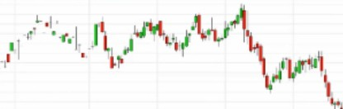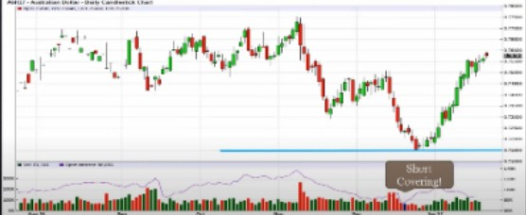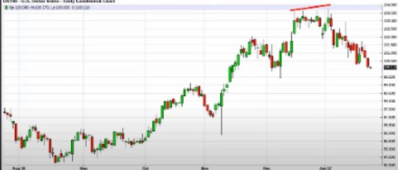

Just because it trades at a **HTF** support level doesnt mean its going to trade higher, but couple it with open interest and the interest rates. We also had SMT with the dollar. When the fundamentals line up with the technicals thats when its high probability



Select a country with a High Interest Rate. Determine the Forex Pair coupling for trades. For example: US *.75"..* vs. Japan -.15".,

Look for strong Resistance on HTF cha11s.

\\:ait for Sma11 :\1oncy clues it is being Sold. Seasonal tendency & or Open Interest confirm. L'SIY\ dircctiunal rnnfirmation qualifies.

***SWISS HA*TIONAL *BANK***

***EUROPEAN CENTRAi. BANK RESERVE SANK OF NEW ZEALAND***

***RESERVE BANK OF AUSTRALIA***

***CURRENTINTERESTRATE***

**-0.75'11,**

-0.1 'lf,

**O'lf,**

1.75'11,

**0,5'11,**

**15'11,**

**0.75'11,**

**025'11,**

**J6 • Japanese Yen . Weekly Nearest Candlestick Chart**

* **Op-0.87500, Hr:0.88830, Lo:O87400, Ct0.88550**

**1 f1 •-1-"'t**

\, I

**.J** \, ,

\,

**1**

***Jul* Sep**

-

- -

tt'

**-14**

**Jon 15**

***Jul***

**Sep**

II

-

t

-

**Jonll**

;·

- -

*ir \t*

***Jul***

**Sep**

-

*i*

**Jon 17**

**1-01000**

**LOOOOO 099000**

**090000**

**097000**

**096000**

**095000**

**094000**

**09l000**

**0.92000**

**091000**

**090000**

**087000**

**006000**

**085000**

**084000**

**OSlOOO**

**0 ll2000**

**081000**

**080000**

**0 79000**

This was the basis on why ICT knew the USDJPY was going higher, the fundamentals and technicals line up. Youll see the bank footprints flow into the market

Use open interest on support levels, otherwise you might get lost He doesnt advise people to trade exotic pairs

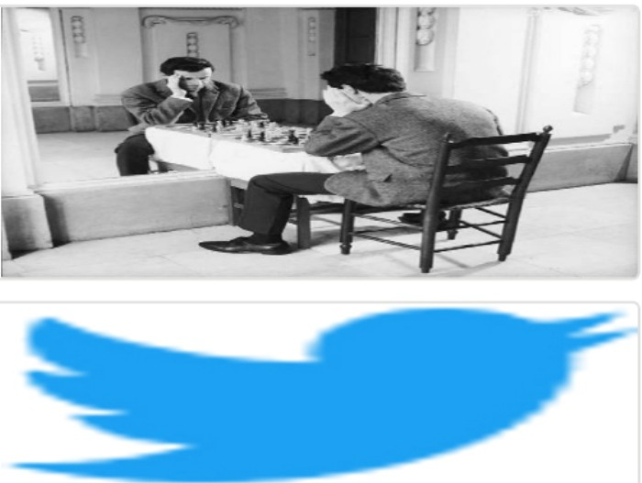Arjo I Twitter, lnstagram I Linktree

Linktree. Make your link do more.

1 https://t.co/HhmmTN1fUI

JavaScript is not available.

***"JI*** https://twitter.com/arjoio